**+**



**Okaya Culture Promotion Group Okaya Int'l Center**

8-1 Saiwaicho Former City Hall 1st Floor, 394-0029

TEL: (0266) 24-3226 FAX: (0266) 24-3229

e-mail: oiea@oiea.jp URL: www.oiea.jp

Winter 2018 edition（英語）

**OIC**

Welfare and Healthcare Benefits

かてい



(福祉医療給付金・ふくしいりょうきゅうふきん・*Fukushi Iryō Kyūfukin*)

**The Welfare and Healthcare Benefits Payment System Has Changed as of August 2018**

What are welfare and healthcare benefits？

It is a system designed to ease the burden of medical expenses so that the disabled, families with infants and children, and single parent households can receive medical treatment with peace of mind.

|  |  |  |
| --- | --- | --- |
| **Qualified Recipients** | **Eligibility Requirements** | **Medical Treatment Covered by Benefits** |
| Infants and Children | Children from the ages of 0 until the March 31st following their graduation at junior high school. | Inpatient and Outpatient Care  (Hospital Dietary Care Expenses) |
| Severely Disabled Adults  Severely Disabled Children | Persons in Grades 1 ~ 2 who receive the special child-care allowance | Inpatient and Outpatient Care  (Hospital Dietary Care Expenses) |
| Persons in Grades 1 ~ 3 who have a physical disability passbook (身体障害者手帳・しんたいしょうがいしゃてちょう・*Shintai Shōgaisha Techō*) (this can be applied to persons over the age of 65 even if they are in Grade 4) |
| Persons with an A1, A2, or A3 special education passbook (療育手帳・りょういくてちょう・*Ryōiku Techō*) |
| For recipients of the disability pension…  ＜under 65 years of age＞  - Recipients in Grade 1, subset No. 9, 10, 11  - Recipients in Grade 2, subset No. 15, 16, 17 (this applies only for   persons under the age of 20 who develop an illness or symptoms)  ＜aged 65 years or older＞  - Recipients in Grades 1 ~ 2 |
| Persons in Grades 1 ~ 2 of the Mental Health and Welfare services who have disability IDs (精神保健福祉手帳・せいしんほけんふくしてちょう・*Seishin Hoken Fukushi Techō*) | Outpatient Care Only (this includes hospitalization in those aged 65 or older) |
| Single Mother Household | - Women who do not have a spouse and are supporting children who   are under 18 years old (if under the age of 20, this lasts until the child   graduates from high school) [this policy includes their children] - Parentless children who are under the age of 18 | Inpatient and Outpatient Care  (Hospital Dietary Care Expenses) |
| Single Father Household | Men who do not have a spouse and are supporting children who are under 18 years old (if under the age of 20, this lasts until the child graduates from high school) [this policy includes their children] |

**Light Blue** Recipient Certificate (あじさい色受給者証・あじさいいろじゅきゅうしゃしょう・*Ajisai iro Jukyūshashō*)

What do recipients pay?

**Light Green** Recipient Certificate (若草色受給者証・わかくさじゅきゅうしゃしょう・*Wakakusairo Jukyūshashō*)

・If you visit a pharmacy, there is a 500 yen charge for every   
 prescription filled at a medical institution.  
・There is a 500 yen charge per month at a medical institution.  
・Hospitalization and outpatient care are difference services.   
  
※If you receive treatment at an Orthopedic clinic (整骨院/接骨院・せいこついん/そっこついいん・*seikotsuin/sekkotsuin*) or out of the prefecture, a bank account transfer will be completed per prior policy.

・If you require outpatient or inpatient care, hospital dietary care during hospitalization, an out-of-prefecture diagnosis, and/or a medical brace and you *don’t* present your recipient certificate, a bank account transfer will be completed per prior policy.

**At the International center, we organize events for foreign nationals**

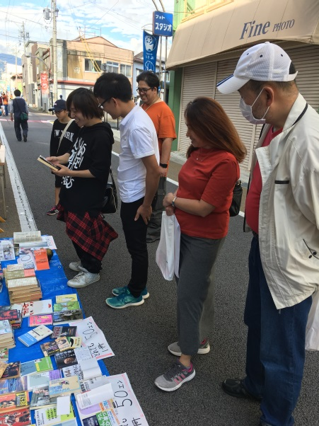

**Okaya City Tour for Non-Japanese Residents**

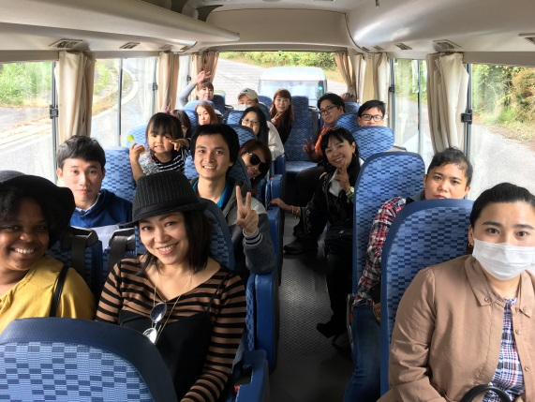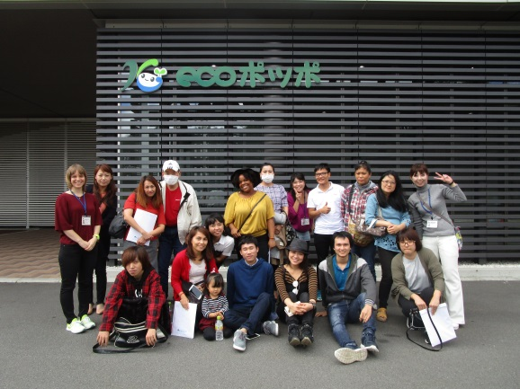

0

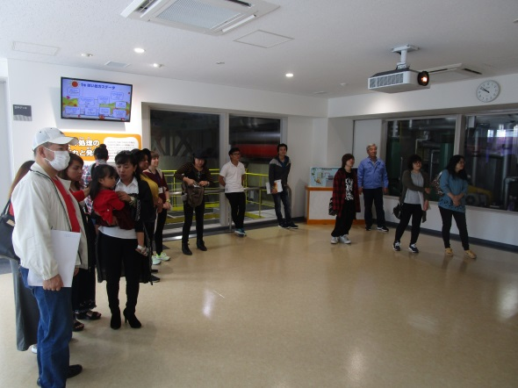

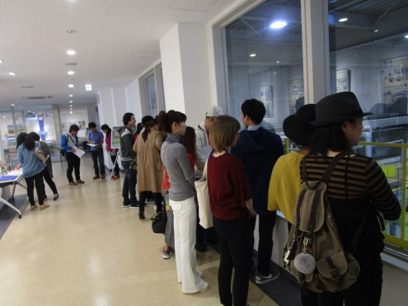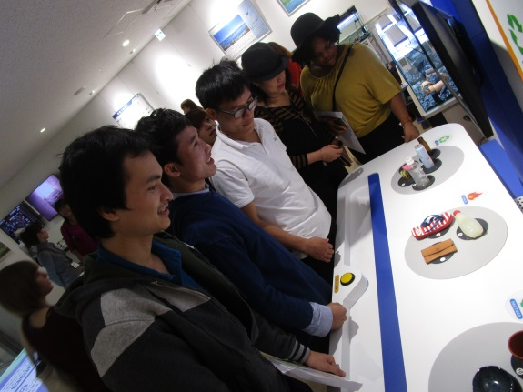

**Japanese Cooking Class**

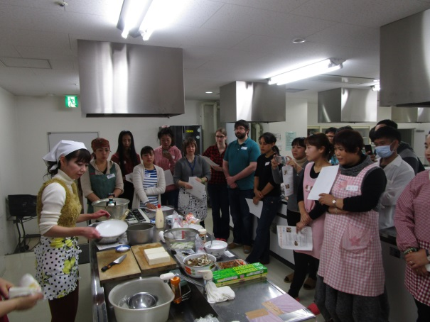

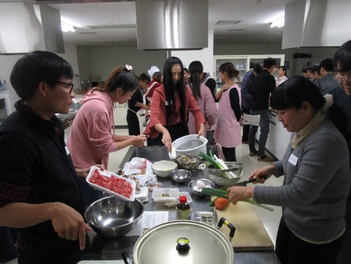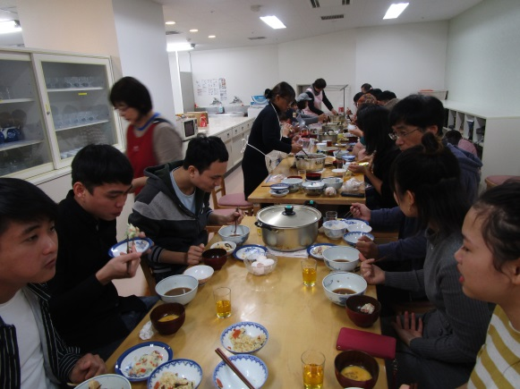



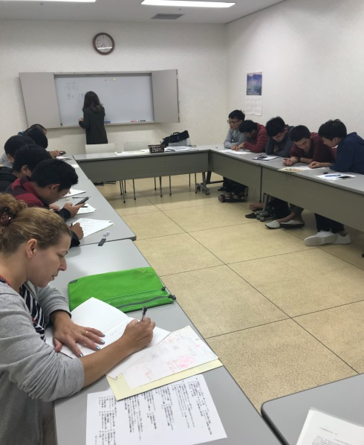

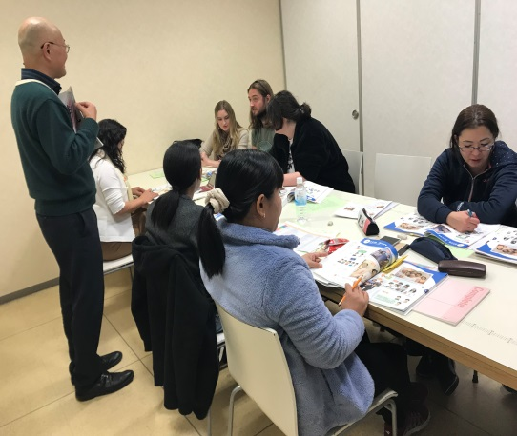

**Japanese Classroom (Free)**

**Check out these other events**

**Christmas Event  
(for elementary school students)**

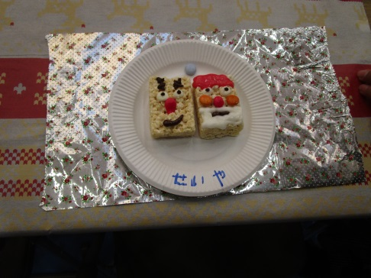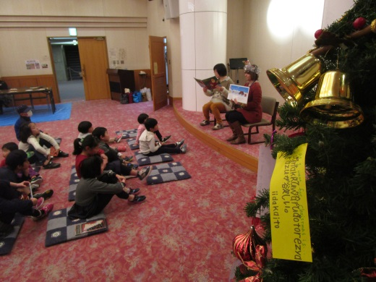

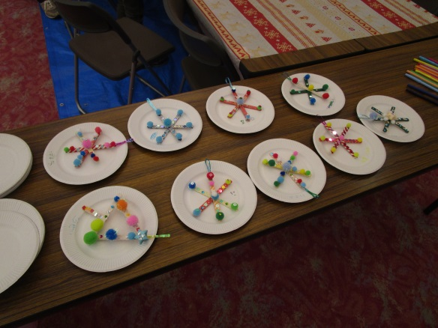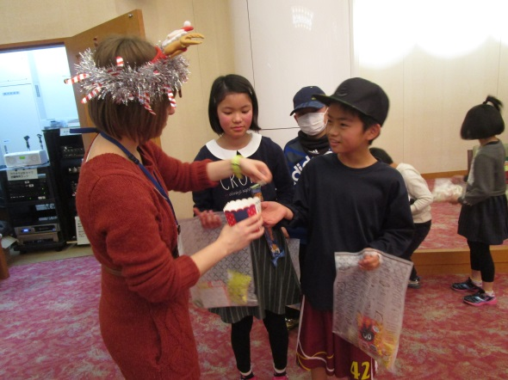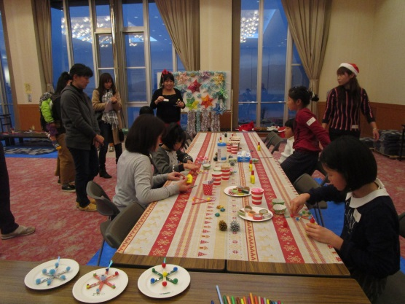

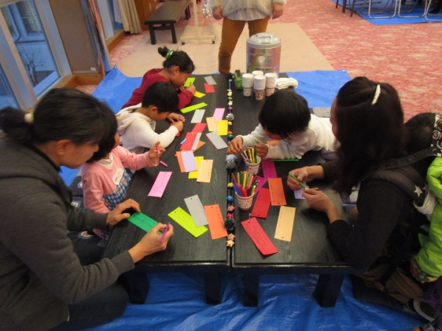

**Our Coordinator for International Relations**

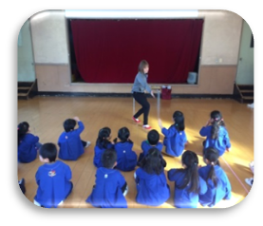

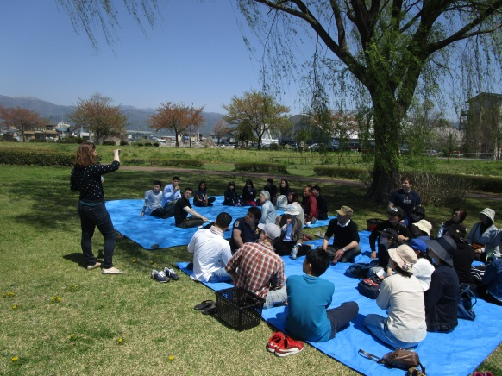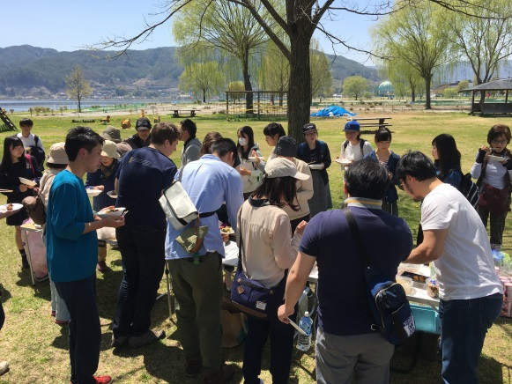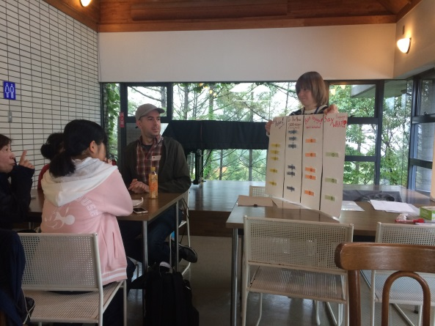

**Okaya English Speech Contest**

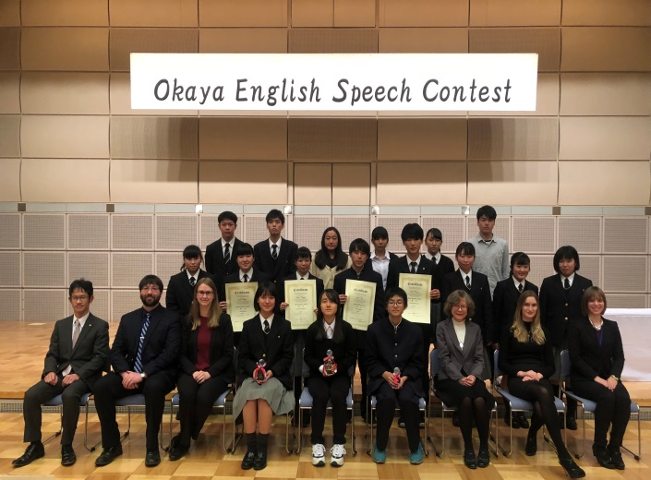

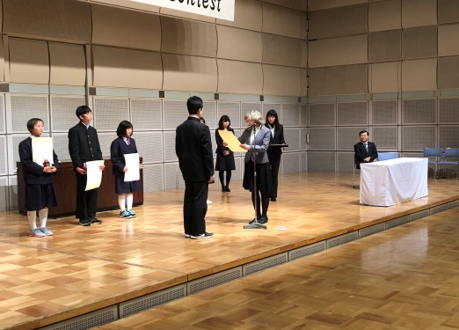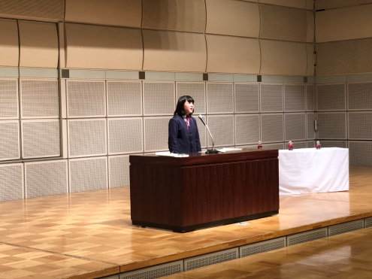

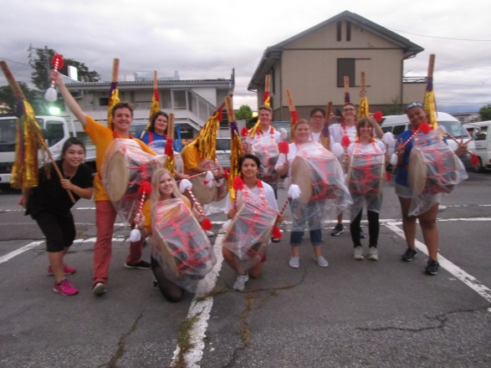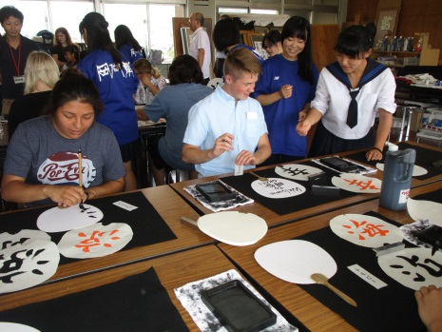

**Sister City Exchange**

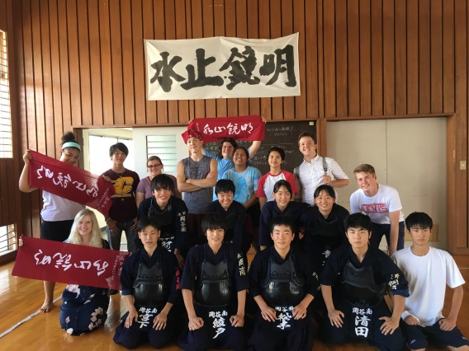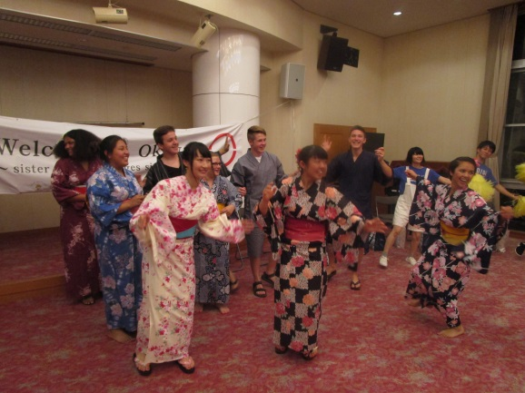





**PUTZ Network Co.,Ltd. （株式会社プツ・ネットワーク）** A multicultural company with multilingual support and support services

**Helpful Information for Foreign Nationals**

**～Information Corner～**

What is PUTZ Network？

In addition to making multiculturalism more of a reality, we are a company who provides multilingual support and support services while aiming to further promote both the growth and principles of multiculturalism.

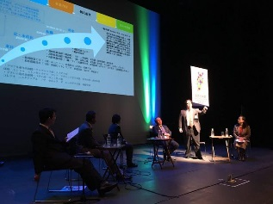

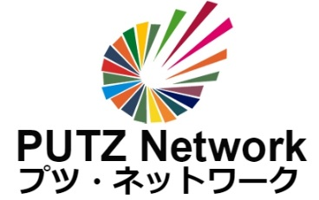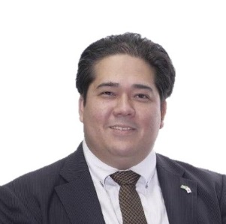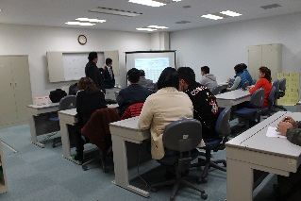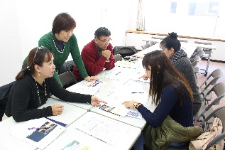

“Through our multilingual and support services based on the principles of multiculturalism, we are expertly working on the essential steps, planning, and projects necessary to promote more diversity and thinking how exactly Japan can incorporate these ideas in modern society.”

Representative Director **Kenji Nishikawa**

**P**articularities

**U**tilities

**T**roubles

**Z**est

**Network**

Our company respects each individual’s unique characteristics and puts public interest first as we endeavor to bring about multiculturalism. Moreover, we eagerly propose improvements and solutions for each multicultural problem we face, and contribute to society and encourage business.

www.putznetwork.com