



**Okaya International Center** 394-8510 Nagano-ken Okaya-shi Sawai-cho 8-1 [TEL:(0266)24-3226](tel:(0266)24-3226) FAX：(0266)24-3229

E-mail:oiea@oiea.jp URL:www.oiea.jp

**Summer Edition July 2015**

**OIC**

This newsletter is distributed four times a year by the Okaya International Center,

with the aim of providing local foreign residents with information necessary for daily life, as well as insight into aspects of Japanese culture.　Please feel free to contact us with your feedback or any questions you may have.



かてい

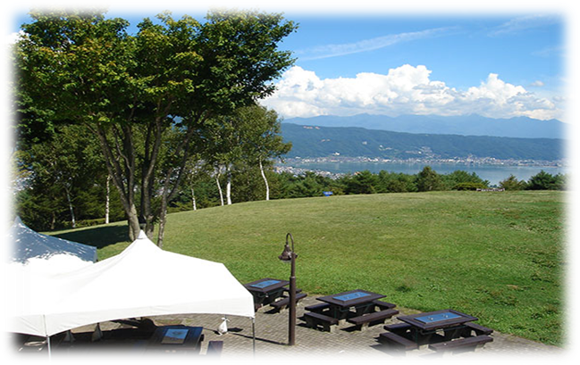

**With things to do for everyone, you can spend the whole day entertained at Yamabiko Park!**

Located on a mountainside at an altitude of 950m at its lowest point and 1020m at its highest, the park has breathtaking views of Lake Suwa and both the Yatsugatake Mountains and the Alps. In addition to the views, the park also has a roller skating area, summer bobsleigh track, and BBQ and dining facilities. Why not spend an enjoyable time with friends and family at Yamabiko Park this summer!

For inquiries, please contact the park on 0266-22-6313



Located on the Lake Suwa side of Suwako Heights, this fun space has beautiful views of the lake and the Yatsugatake mountain.

With a foot bath, paddling area, and play equipment, both sightseers and locals enjoy gathering here.

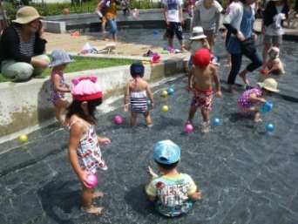

**[](http://www.google.co.jp/url?sa=i&rct=j&q=%E5%9B%BD%E9%9A%9B%E5%8C%96%E3%82%A4%E3%83%A9%E3%82%B9%E3%83%88&source=images&cd=&cad=rja&docid=4jwn7N_NeLdjqM&tbnid=RPArF7hHzkAY4M:&ved=0CAUQjRw&url=http://www.pref.hokkaido.lg.jp/ss/ssa/ksk/sougou/newplan/tenbo4.htm&ei=2YN4UaLTNomwiAe3l4HICg&bvm=bv.45645796,d.aGc&psig=AFQjCNFNBEb1zxyg7GSwm0EGZn8e01a-Dg&ust=1366938962088056)**

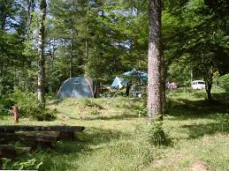

The activity center is located in a park at the peak of the Enrei mountain pass. The area is one of natural beauty and is a base for outdoor activities. The activity center operates both a campsite and mallet golf course.

The forest in the surrounding area has been awarded Kotori no Mori status by the Ministry of the Environment and attracts many bird watchers.   
For inquiries, please contact the center on 0266-23-8028





**Q**: What is the national census?

**A**: It is the country's most important statistical survey and is to be filled out by all people/households in Japan. Based on the Statistics Act, the census is to be carried out every 5 years in order to investigate the current population and actual conditions of households.

All people resident in Japan regardless of nationality are required to complete the survey.



**Q**: Of what use are the results of the census?

**A**: The results are used for the planning of natural disaster countermeasures, for welfare purposes, and to enhance our general living environment. In short, they are indispensible in the building of Japan's future.

The data collected is also used in research by universities and think tanks to analyze socioeconomics and make appropriate proposals.



**Q**: What if I'm busy with work... Do I still need to complete the census?

**A**: If the census is not completed correctly by everybody, the results collected will not be an accurate representation of the status quo in Japan which will lead to inaccuracies in the planning and implementation of future policies based on the results. This in turn may affect fair and efficient government administration.

To avoid this and ensure just and efficient government administration based on accurate statistics, everyone resident in Japan is required to complete the census without exception.



**Q**: There are certain questions I'm uncomfortable answering... Do I still have to answer them?

**A**: Under the Statistics Act, all applicable persons are obliged to complete and submit the consensus, and in the event that false information is given or that the furnishing of information is refused, penalties are stipulated.

The same act also stipulates that all information collected must be treated with the strictest confidentiality and details how census survey forms are to be handled. Penalties for not complying with the above are also stipulated. Please complete the census with peace of mind and make sure to submit it.



**Q**: Is the census covered by the Act on the Protection of Personal Information?

**A**: No, the census which is based on the Statistics Act is not covered by the Act on the Protection of Personal Information. The reasons for that are below:

* Personal information collected in the census is compiled and processed in a way so that individuals cannot be identified. Only information in this format is used and shared.
* The Statistics Act strictly forbids the use of census answers given for any purpose other than statistical analysis and strictly defines how personal information is to be handled.



For the current census, an online ID will be first be given out. Households not submitting the census online within the stipulated period will then be sent a paper census form.

Process complete

Answer online via PC or smartphone

Distribution of online IDs after verifying resident status

paper census sent to households failing to submit a completed census online

Submit completed census by post or to a census official



This year is the 50th anniversary of the Okaya - Mt. Pleasant sister city relationship.

In order to celebrate this occasion, 20 guests including the Mt. Pleasant mayor James Holton will be visiting Okaya from August 10th to 14th.

During their visit, they will stay with host families, learn about the cultures of Japan and Okaya, and experience the Taiko Festival.

On the morning of August 12th at 8.30am in Kohan Koen (south side of the mallet golf course) a traditional ceremony will be performed by a member of the Saginaw Chippewa Indian Tribe. Members will form a circle and give prayer as tribe member Judy Pamp uses sacred medicines and instruments to conduct the ceremony.

Please feel free to join in this exciting event and learn a little about Native American culture.

The photos on the right show the ceremony and group of visitors that came to Okaya for the sister city relationship's 40th anniversary.

The city will be celebrating the 50th anniversary in equally as much style this year.



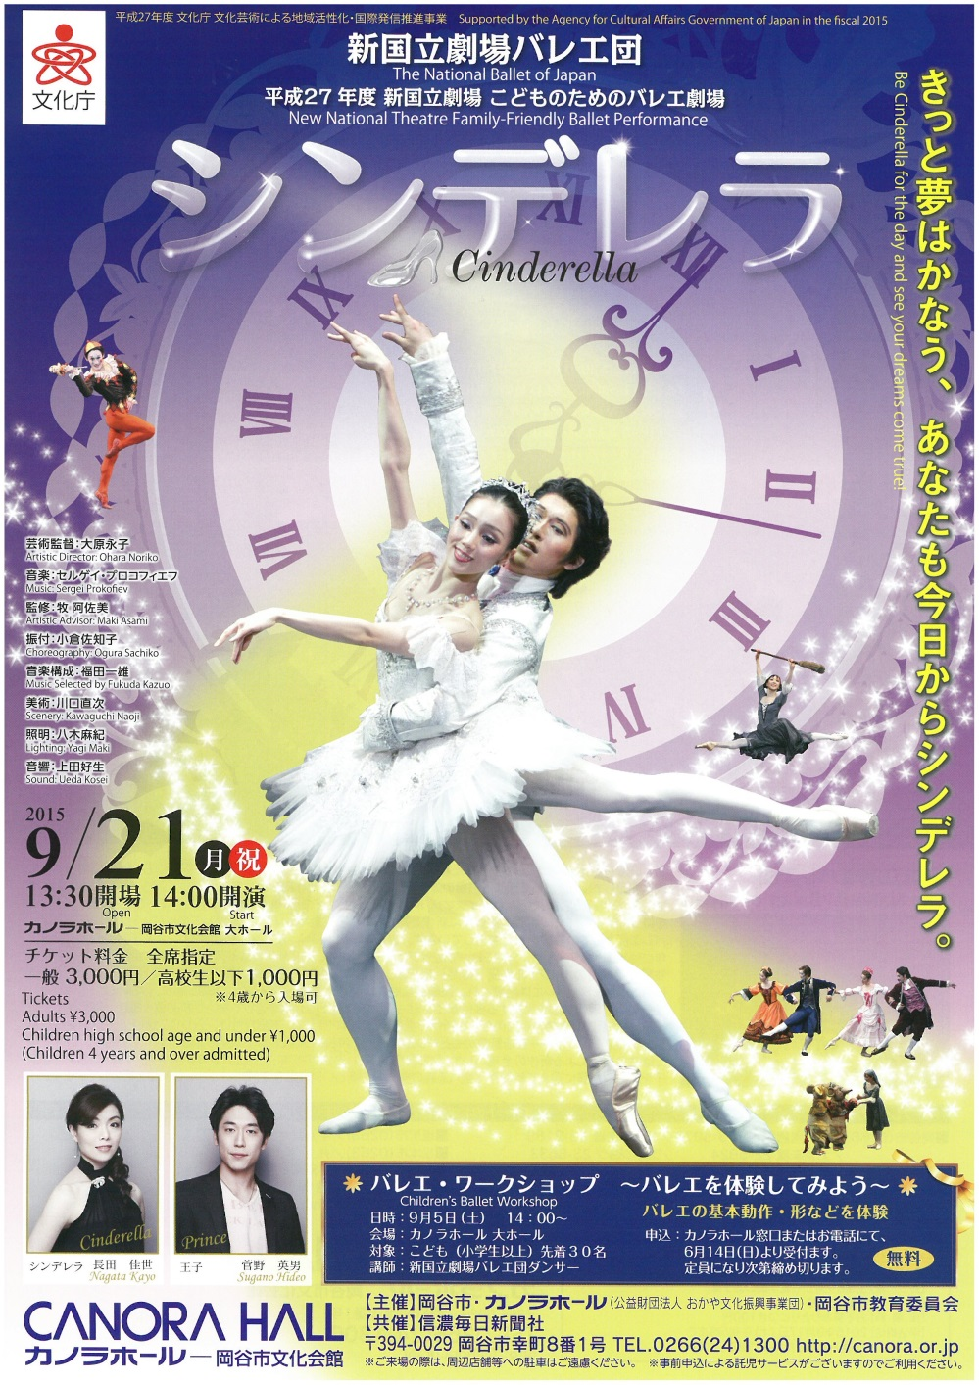

**Date:** Sept 21st

**Venue:** Canora Hall

**Time:** Hall opens at 13:30 with the performance starting at 14:00

In the run up to the Tokyo Olympics and Paralympics scheduled to be held in 2020, Japan's Agency for Cultural Affairs is aiming to encourage more foreign nationals to visit Japan for arts and cultural activities.

As part of the agency's subsidy program, Canora Hall has received funding to enable the performance of Cinderella to take place and would like to invite foreign residents of the Okaya area to attend the performance. Canora Hall has a limited number of tickets to give to foreign residents free of charge.

To reserve one of these special tickets, contact the　Okaya International Center on 0266-24-3226





Why not ride around Lake Suwa by bicycle！！

Okaya Station to Kamaguchi Suimon approx. 10 mins

Kamaguchi Suimon to Suwako Heights approx. 10 mins

A lap of Lake Suwa approx. 90 mins

Rental Price:\ 500 per day (8am - 7pm)

The rental service is available all year round except over the New Year period.

For inquiries, contact the Okaya Station Bicycle Park on 0266-24-5258

