



**（公財）おかや文化振興事業団国際交流センター**

〒394-8510岡谷市幸町8-1岡谷市役所１階[TEL:(0266)24-3226](tel:(0266)24-3226)　FAX：(0266)24-3229

E-mail:oiea@oiea.jp URL:www.oiea.jp

**2014年　　７月号**

**OIC**

このニューズレターは()おかやセンターがのにのをおえしながら、なにつをしようとごと4しております。ご. おいわせはへおせください。



1.Okaya Taiko Festival

2.Okaya Toronagashi & Fireworks

3.Yamabiko Park

4.Bicycles

Okaya City's Okaya Taiko Festival, which has continued since 1969, is considered one of the most prominent large-scale Japanese Taiko performances nationwide. The festival is held on the 13th and 14th of August every year. The festival kicks off with performances around the city, the main street leading up from the station is pedestrianized, and a lively parade featuring Minakoi Wassaka dancing is also held. As dusk approaches, a portable shrine is paraded around and more dancing can be seen. Once it becomes dark, the festivities move to the outdoor main stage where a truly spectacular 300-person taiko performance unfolds. This 300-person performance, which can be heard in the Heavens, is Japan's largest such performance. Performing taiko together with 300 people is no easy feat and should definitely not be missed! Come and experience the overwhelming force of the Okaya Taiko Festival this summer!

[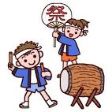](http://www.google.co.jp/url?sa=i&rct=j&q=&esrc=s&source=images&cd=&cad=rja&uact=8&ved=0CAQQjRw&url=http://www.misaki.rdy.jp/illust/child/hoiku/natumaturi/sozaitext/303.htm&ei=HTiqU6rGFYbKkwWusoDIBg&bvm=bv.69620078,d.dGI&psig=AFQjCNGXhz7clotQurhsVPr_GidaARdG0g&ust=1403750813398885)

[](http://www.google.co.jp/imgres?imgurl=http://www.paylessimages.jp/preview/xf/pic1012/xf3055055176.jpg&imgrefurl=http://www.paylessimages.jp/detail_xf3055055176.html&h=400&w=320&tbnid=XZPP-EFtPv3s-M:&zoom=1&docid=TbwMzGk8goWryM&ei=JWuqU-PQMM6IkQXjh4CgAw&tbm=isch&ved=0CIYBEDMoXjBe&iact=rc&uact=3&dur=248&page=4&start=94&ndsp=33)

**What is Toro Nagashi?**

Toro Nagashi is a custom carried out on the last day of Obon throughout Japan. On this day, the spirits of deceased loved ones are sent down rivers on floating lanterns and small boats made from straw.

Due to the beauty and fairytale-like scene created by the lit lanterns that are floated out onto the water in the dark, in areas where this custom is carried out on a large scale, it has become both a way of grieving for deceased loved ones and an event that attracts tourists.

[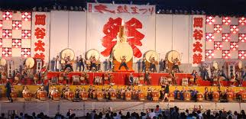](http://www.google.co.jp/imgres?imgurl=http://event.adtecsys.com/okaya/taiko_f2010/images/m_t1.jpg&imgrefurl=http://event.adtecsys.com/okaya/taiko_f2010/index.html&h=389&w=800&tbnid=mwncuCUAL1VM5M:&zoom=1&docid=Ufg6zOQ-lW4bZM&ei=rDOqU_aaF8mkkwXWjIHADg&tbm=isch&ved=0CE4QMygoMCg&iact=rc&uact=3&dur=44&page=2&start=21&ndsp=27)

[](http://www.google.co.jp/imgres?imgurl=http://1.bp.blogspot.com/-8fF1kghKiZk/UdzBQYK3DQI/AAAAAAAAWQc/Zkx80N0bLnA/s800/tourou_nagashi.png&imgrefurl=http://www.irasutoya.com/2013/10/blog-post_71.html&h=658&w=683&tbnid=k1A1sUKDGgX_ZM:&zoom=1&docid=DNbf7tSs0DfWoM&ei=MWSqU4WcPIjJkQW924DQAg&tbm=isch&ved=0CGAQMyhYMFg4ZA&iact=rc&uact=3&dur=1140&page=7&start=184&ndsp=32)

When you think of summer in the Suwa area, the famous Suwa Firework Festival, held on the 15th of August, surely springs to mind, but you should not miss the smaller scale firework festival and Toro Nagashi which take place across the lake on Okaya's shores. The lanterns floated out onto the lake number more than 1000 and an impressive 2000 fireworks are launched from the lake. Kohan Koen across from the Kamaguchi Suimon is one of the best spots to take in the festival.

[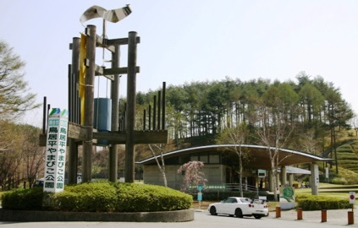](http://www.google.co.jp/url?sa=i&rct=j&q=&esrc=s&source=images&cd=&cad=rja&uact=8&docid=kXRMZ13pytVLLM&tbnid=fZb22c7AqgjuhM:&ved=0CAUQjRw&url=http://r34.fc2web.com/okaya_touring.html&ei=qoiiU6DXKNDq8AXXz4HICA&bvm=bv.69411363,d.c2E&psig=AFQjCNHL5QbHZu-qNtKDBLM5wwbuKO7iaA&ust=1403247049302627)

Okaya's Toriidaira Yamabiko Park is a park located at an elevation of between 950-1020m on a mountainside overlooking Lake Suwa. On a clear day, you can get a superb view of the Yatsugatake mountain range. The park boasts a range of different sports facilities and play equipment in the most beautiful of settings. Visit Yamabiko Park with family, friends, or even a special someone and enjoy summer to its fullest!

**Ｎａｔｕｒｅ**

★Ｃｅｎｔｒａｌ　Ｐｌａｚａ　－　With a water feature and shady trees, this is a very pleasant entrance to the park

★Mountain Stream & Picnic Area - Relax in beautiful surroundings

★Ikoi Plaza・・・BBQ among the trees in this luxuriantly green space

[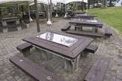](http://www.nagano-navi.net/images/park/20204001_21.jpg)[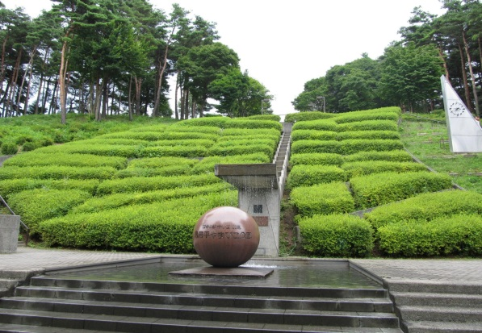](http://www.google.co.jp/url?sa=i&rct=j&q=&esrc=s&source=images&cd=&cad=rja&uact=8&docid=Q_-Sq1oGUzfZZM&tbnid=KyZY8oSSlgRgQM:&ved=0CAUQjRw&url=http://blog.goo.ne.jp/koma_stein/e/77c3549741564c47c276ada78979dba6&ei=v2iiU4XHKtD28QX1-IKQBQ&bvm=bv.69411363,d.c2E&psig=AFQjCNGBiIfh18Sgk6VTe5HFc88gGG1dOA&ust=1403238676612813)

**Ｆｕｎ**

★Battery Powered Cars - A large selection of small vehicles for small children to ride on

★Funny Bikes - around 20 different kinds of interestingly shaped bikes

★Giant Slide - A long slide for both children and adults

★Dog Run - A free dog run where you can let your dog of its lead

[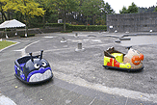](http://www.nagano-navi.net/images/park/20204001_07.jpg)

[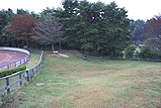](http://www.nagano-navi.net/images/park/20204001_22.jpg)[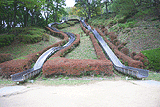](http://www.nagano-navi.net/images/park/20204001_02.jpg)

[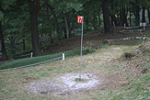](http://www.nagano-navi.net/images/park/20204001_23.jpg)[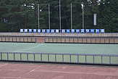](http://www.nagano-navi.net/images/park/20204001_20.jpg)

**Ｓｐｏｒｔｓ**

★Cycling - Enjoy an exhilirating bicyle ride around the park's 1.4km cycling course

★Mallet Golf - A 36 hole woodland mallet golf course

★Disc Golf - Compete with friends by throwing frisbees into designated baskets

★Summer Bobsleigh - Take a speedy ride down the mountain on a specially designed bobsleigh

★Tennis Courts - Bring your racket and have a knock-about

★Sports Area - Can be used to practice and play baseball and softball

★Roller Skate Rink - A 200m rink which also boasts a hockey court

[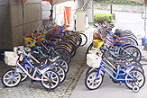](http://www.nagano-navi.net/images/park/20204001_18.jpg)

[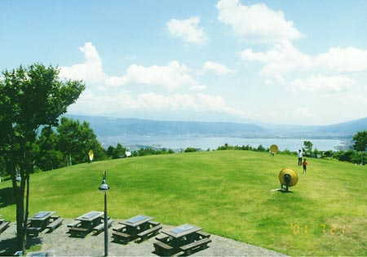](http://www.google.co.jp/url?sa=i&rct=j&q=&esrc=s&source=images&cd=&cad=rja&uact=8&docid=qpdKCEZ_ZeHCAM&tbnid=y1XVmyfsP4YHpM:&ved=0CAUQjRw&url=http://yakei.jp/japan/spot.php?i=yamabiko&ei=fIqiU-K1NM3r8AWTvYCACg&bvm=bv.69411363,d.c2E&psig=AFQjCNE9oHWtT9jVz1D2KmkPBsYmqvaiAg&ust=1403247263767483)[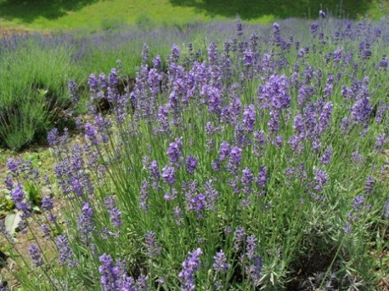](http://www.google.co.jp/url?sa=i&rct=j&q=&esrc=s&source=images&cd=&cad=rja&uact=8&docid=mF7SU4tQBDPEbM&tbnid=O-MJjbtv89R71M:&ved=0CAUQjRw&url=http://azusado.blog73.fc2.com/blog-date-200906.html&ei=AoyiU5uXCsXc8AWiroD4AQ&bvm=bv.69411363,d.c2E&psig=AFQjCNE9oHWtT9jVz1D2KmkPBsYmqvaiAg&ust=1403247263767483)

**Seasons & Scenery**

★Lavender Garden - Enjoy picking lavender （Peak Season: June - July）

★View Plaza - A popular spot with a breathtaking view of Lake Suwa and the Yatugatake mountain range

[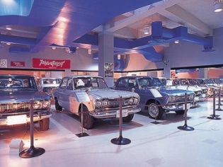](http://www.google.co.jp/url?sa=i&rct=j&q=&esrc=s&source=images&cd=&cad=rja&uact=8&docid=dIIcTekrtI80aM&tbnid=GCq-Y752xwfeOM:&ved=0CAUQjRw&url=http://www.mapple.net/spots/G02000097901.htm&ei=1YyiU9a8N9Tj8AXh24CYDw&bvm=bv.69411363,d.c2E&psig=AFQjCNE9oHWtT9jVz1D2KmkPBsYmqvaiAg&ust=1403247263767483)

**Facilities**

★Park Administrative Office and Shop - Local products and souvenirs for sale here

★Skyline Museum - Ideal for car fantics! A museum with skyline cars on display that chronicle the ages

★Restaurant & Yakiniku Corner - Dine with an exquisite view. Yakiniku is by reservation

[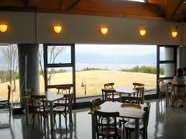](http://www.google.co.jp/imgres?imgurl=http://yamabiko.okaya-park.com/images/04restaurant.jpg&imgrefurl=http://yamabiko.okaya-park.com/goriyou/bbq/&h=450&w=600&tbnid=W8W-AWxxkN4YaM:&zoom=1&docid=8MEtKqtOgdj2fM&ei=rIeiU7z5NceNuATskoCgDw&tbm=isch&ved=0CHsQMyhXMFc&iact=rc&uact=3&dur=1775&page=4&start=74&ndsp=22)

**Yamabiko Park Opening Hours**

Open from：Mid-april to mid-November（Closed during winter）

Opening hours：９：３０am - 5：００pm

Closed：Every Tuesday

※If Tuesday falls on a national holiday, the park is closed on the following day, on wednesday, instead.

※During Golden Week and the summer season, the park is open 7 days a week.

Please see the homepage for more information.

http://yamabiko.okaya-park.com/

**スポーツ**

**スポーツ**

**スポーツ**

Bicycles are convenient, green, and a great way to get some exercise, but are considered light vehichles. As with any vehicle, dangerous driving can lead to accidents. It is important to know road rules and manners when riding bicycles.

[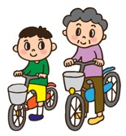](http://www.google.co.jp/url?sa=i&rct=j&q=&esrc=s&source=images&cd=&cad=rja&uact=8&docid=Bys8S3Kh58evBM&tbnid=r00g8H0C4icRmM:&ved=0CAUQjRw&url=http://www2.city.suginami.tokyo.jp/guide/guide.asp?n1=80&n2=1450&n3=200&ei=sLmjU7GIKMz-8QXgjYG4CQ&bvm=bv.69411363,d.c2E&psig=AFQjCNEQEikjYcVG--qyDWK3cXd_YFubEw&ust=1403324926700388)

★When cycling along the roadside, you must cycle on the left side only!★

★

Until a recent change in the law, bicycles could be ridden along the roadside on either the left or the right. Bicycles can now only be ridden on the left. Failing to adhere to this can result in a maximum jail sentence of 3 months or a fine of up to ¥50,000.

[](http://www.google.co.jp/url?sa=i&rct=j&q=&esrc=s&source=images&cd=&cad=rja&uact=8&docid=aLIsJL3Ivb5F4M&tbnid=hLECeqk5ylbkpM:&ved=0CAUQjRw&url=http://www.police.pref.hyogo.jp/topics/bicycle/rosoku/index.htm&ei=J7qnU8DGHoLf8AWN7oFw&bvm=bv.69411363,d.dGc&psig=AFQjCNFxBvISGE8iRsljPWK_xUsc9_iolg&ust=1403587463081064)What is meant by roadside?

The term describes a road with a white line painted on its surface marking a space for pedestrians in place of a sidewalk.

**Q：**Where should I cycle if the road has a sidewalk?

**A：**Bicycles should be ridden on the left-hand side of the road the same as cars. However, in the following cases, bicycles can also be ridden on the sidewalk.

●When there is a sign giving permission to cycle on the sidewalk.

●If you are under 13, over 70, or disabled.

[](http://www.google.co.jp/url?sa=i&rct=j&q=&esrc=s&source=images&cd=&cad=rja&uact=8&docid=izWGnwmdeRV8IM&tbnid=7VnrZ9SBz2Ic3M:&ved=0CAUQjRw&url=http://www.bicyclecolor.com/tan/archives/2013/01/post-47.html&ei=9L-nU9rjNdjf8AWSm4KgDA&bvm=bv.69411363,d.dGc&psig=AFQjCNGrTBEG7BKHO58HpbQWYf-cnZ02-w&ust=1403588970825283)●When it is dangerous to cycle on the road (e.g. when roadwork is taking place, if the road is obstructed by a car, etc...)

★Bicycles without brakes must not be ridden!★

●Bicycles without breaks or the necessary equipment to ensure safe stopping can be pulled over by police and subjected to an inspection.

●If bicycles are not fitted with the necessary equipment or if not in working order, police can demand that you fix the issue and prohibit you from riding your bicycle.

**Ahh, there are no brakes！**

[](http://www.google.co.jp/url?sa=i&rct=j&q=&esrc=s&source=images&cd=&cad=rja&uact=8&docid=No_XnEId1sh0xM&tbnid=hT8M0TbOuL8GnM:&ved=0CAUQjRw&url=http://kanzaki.sub.jp/archives/002470.html&ei=5sGnU6S9FsPo8AWJt4DwAQ&bvm=bv.69411363,d.dGc&psig=AFQjCNHQObQ2P4hER8hPrRpMQjXJzzw6TA&ust=1403589424249765)