**はい**



**Okaya International Center** 394-8510 Nagano-ken Okaya-shi Sawai-cho 8-1 [TEL:(0266)24-3226](tel:(0266)24-3226) FAX：(0266)24-3229

E-mail:oiea@oiea.jp URL:www.oiea.jp

**Winter Edition**

**OIC**

This newsletter is distributed four times a year by the Okaya International Center,

with the aim of providing local foreign residents with information necessary for daily life, as well as insight into aspects of Japanese culture.　Please feel free to contact us with your feedback or any questions you may have.



[](http://www.google.co.jp/url?sa=i&rct=j&q=&esrc=s&frm=1&source=images&cd=&docid=WvXtpDpsscw98M&tbnid=pr3FWYWaCMvvtM:&ved=0CAUQjRw&url=http://www.misaki.rdy.jp/illust/child/icon/huyu2/sozaitext/2303.htm&ei=rIK6Uui1IMSmlQWJx4CoAg&bvm=bv.58187178,d.dGI&psig=AFQjCNET_cYhbBgdEjrRnqgpiNTRy-rGYw&ust=1388041232980493)[](http://www.google.co.jp/url?sa=i&rct=j&q=&esrc=s&frm=1&source=images&cd=&cad=rja&docid=32VxcCpK7Z1owM&tbnid=CmNoNJlebuuU4M:&ved=0CAUQjRw&url=http://www.shizuoka-pho.jp/kodomo/kamoku/shinzou/letter/004.html&ei=o3S6UoD_FIaIkAXFxYCACg&bvm=bv.58187178,d.dGI&psig=AFQjCNG_WVTvMpQrTNrBMUkidVL5YCNX0g&ust=1388037637116359)

Staying indoors in the warm during winter means we often don`t get enough exercise. Our bodies natural defenses also tend to weaken. Paying attention to your health at this time of year is especially important. Below are a few points to help you spend the cold Okaya winter in good health.

**Diet** - It`s important to eat the right kind of food. Citrus fruit and vegetables are high in vitamin C which is good for the body`s immune system. For a long time it has been said that eating Satsumas will prevent you from getting a cold. For vitamin A which is also beneficial in preventing colds you should eat plenty of liver and carrots. Pumpkin, broccoli, spinach and other greens have the added benefit of containing both vitamins A and C.

**Humidifying your Home -** Germs tend to like low temperatures and dry places. When the humidity in a room drops below 40% the air becomes dry and germs thrive. In order to prevent this from happening you should keep your home warm and use a humidifier in conjunction with heating equipment. The ideal humidity of a room is between 55-65%.

**Bathing** - When it gets cold, blood circulation worsens. For people who feel their legs, hands, and lower back are always cold, a warm bath can be just the trick. 38-40 Celsius is an ideal temperature. Before bathing warm up the bathroom and changing room, and drink some water to make sure you are nice and hydrated. It is recommended to soak in the bath for between 15-20 minutes, but take care as many bathroom accidents occur in winter.

**Cold Prevention** - For a long time here in Japan, it has been said that hand washing, gargling, and wearing masks is an essential way to prevent colds. Even now evidence shows this to be the most effective preventative measure.

**Hand washing:** Colds are not only spread by coughs and sneezes but also by germs on the hands that enter our bodies through our mouths and noses. When washing your hands, spend 15 seconds or so working the soap into a lather. Make sure to wash well between your fingers as well as the tips

**Gargling:** This is important to prevent germs from settling in the mouth and throat. Gargle for 15 seconds and do this 2 or 3 times in a row. You should try and do this 3 times a day.

**Wearing Masks:** By simply wearing a mask you can keep the air that you breathe nicely humidified.

**Exercise -** When it gets cold we stay home, exercise less, and get lazy. To stay in shape and keep up our strength in winter it is important to some exercise. Make some time and go for a walk or do something you enjoy. Dont do anything too strenuous and remember to keep yourself hydrated.

**Clothing -** Fasten clothing to avoid body heat escaping and rather than wearing thick items of clothing, wear several thinner layers. Scarves, gloves, thick socks, and leg warmers will also help you feel that little bit warmer.

The Immigration Bureau's Electronic Notification System is a system whereby notifications to be submitted to the Minister of Justice may be made through the Internet. The system is only available to mid/long-term residents and institutions they belong to. Please note that notifications may still be made by post or at immigration bureau offices in person.

Mid- to long-term residents are foreign nationals residing legally in Japan for the mid- to long-term with resident status under the Immigration Control Act. **They do not fall into any of the categories below.**

★Persons granted permission to stay for 3 months or less

★Persons granted “Temporary Visitor” status

★Persons granted “Diplomat” or “Official” status

★Persons recognized by the Ministry of Justice ordinance as equivalent to the foreign nationals mentioned above (Specifically, staff of the Japanese office of the Association of East Asian Relations and the Permanent General Mission of Palestine in Japan who have “Designated Activities” status, and their families.

[](http://www.google.co.jp/url?sa=i&rct=j&q=&esrc=s&frm=1&source=images&cd=&cad=rja&docid=VGNkzaIHTPLfWM&tbnid=pnG9Y4cF1qNLtM:&ved=0CAUQjRw&url=http://www.learn-s.co.jp/shop/irohanippon/index.aspx&ei=dnjPUqfZKs3jlAXIkYCwBw&bvm=bv.59026428,d.dGI&psig=AFQjCNHqfCCaA0ycEOSkgZEmWIlFyD65XA&ust=1389414873717347)★Special permanent residents

★Persons with no resident status

★**Affiliated Organization Notification**

In case a mid- to long-term resident with "Engineer" or another employment status (excluding "Artist," "Religious Activities," and "Journalist"), or "Student" or another learning status, leaves an organization (employer or educational institution) he/she belongs to (due to termination of contract) or moves into another organization (on a new contract), or such an organization changes its name, location, or breaks up, the resident has to notify the incident to the Ministry of Justice by visiting a Regional Immigration Office or sending a notification to the Tokyo Regional Immigration Bureau, within 14 days of the incident.

★**Spouse Notification**

A mid- to long-term resident who is married, has resident status of "Dependent," "Designated Activities," "Spouse or Child of Japanese National," or "Spouse or Child of Permanent Resident" and who loses his/her spouse by death or divorce has to notify the Immigration Bureau within 14 days of the event.

**[](http://www.google.co.jp/url?sa=i&rct=j&q=&esrc=s&frm=1&source=images&cd=&docid=5j-qXx-RxNaWJM&tbnid=6tZ3lI1zBJ4VrM:&ved=0CAUQjRw&url=http://jp.clipartlogo.com/free/question.html&ei=cljPUpuZBMrlkAWBi4CwCQ&psig=AFQjCNEA0roma07LGi8sUnag4MeHN9ma_g&ust=1389406589309291)**

**Q:　I heard that name changes, change of nationality, relocation to a new town or city and other such changes need to be reported to the Regional Immigration Office. Is it possible to do this using the e-notification system?**

**A:** Change of name, nationality, sex, and relocation to a new town or city all need reporting within 14 days of the said change. Unfortunately however, this cannot be done using the new e-notification system. All of these changes must be reported to the Regional Immigration Office in person. Please note that you do not need to notify the Regional Immigration Office of a change in address if you are moving within a particular town or city. This should be reported to your local municipal office.

**Q: If you fail to submit a necessary notification to the Immigration Bureau or provide false information, what are the penalties?**

**A**: As a mid- to long-term resident, if you fail to file a necessary Spouse Notification or Affiliated Organization Notification within the required 14 days, you risk a fine of up to 200,000 JPY. The submission of false information carries the risk of a jail sentence of up to 1 year or a fine of up to 200,000 JPY. If deemed severe enough to warrant a prison sentence, deportation may also be considered.

**Q: Is it necessary to notify the Immigration Bureau of marriage and remarriage?**

**A:** No it is not. It is only necessary to submit a Spouse Notification if you lose your spouse by death or divorce.

**Q: Can the system be accessed using cell phones connected to the internet?**

**A:** There is a chance that cell phones may not display information correctly so it is recommended to access the system from a PC.

**Q: Can the system be used in languages other than Japanese?**

**A:** Information can be displayed in Chinese, English, Korean, Spanish, Portuguese, and Tagalog, but can only be entered in Japanese (with the exception of specific fields which call for data to be entered in alphabet form).

**[](http://www.google.co.jp/url?sa=i&rct=j&q=&esrc=s&frm=1&source=images&cd=&cad=rja&docid=e1KpwQMCPYztHM&tbnid=DwMoOTgsRM1a2M:&ved=0CAUQjRw&url=http://illustrain.com/category/pc&ei=BVvPUrKkB4GHlAWY74DgBQ&psig=AFQjCNFKB84BofLGWN2dkTT4EqY1o1Cknw&ust=1389407285312540)**

★You can file notifications online from anywhere.

★There is no fee.

★The service is available 24 hours a day 365 days of the year.

★The risk of error is reduced as the system checks for blanks and missing information automatically.

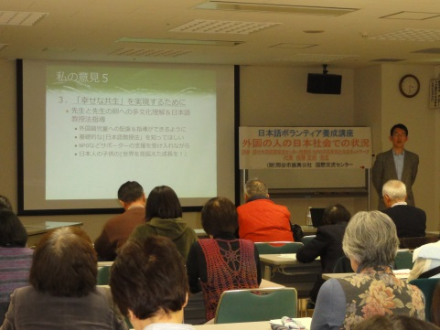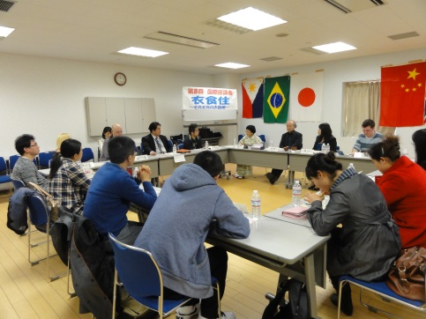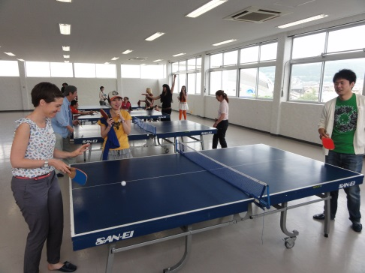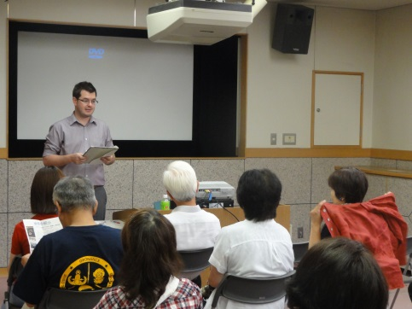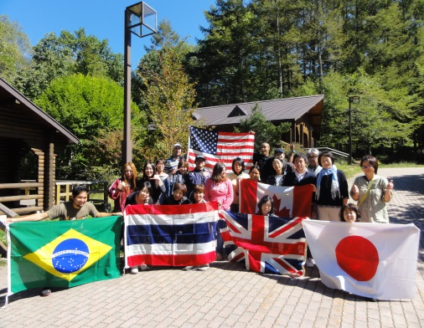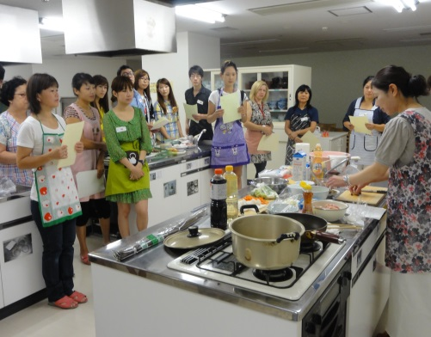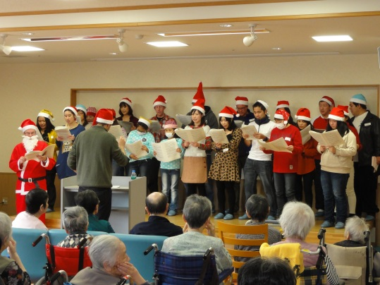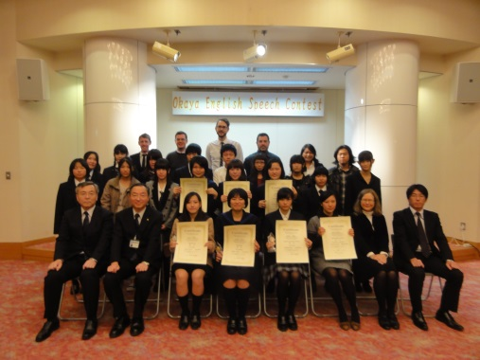

**Christmas Carols**

**City Tour for Foreign Residents (Fall)**

**City Tour for Foreign Residents (Spring)**

**Okaya International Film Festival**

**Japanese Language Volunteer Training Course**

**International Roundtable discussion**

**Okaya English Speech Contest**

**OIC Commemorative Event**

**Japanese Cooking Class for Foreign Residents**

**Mount Pleasant Sister City Exchange Program**

**English Camp**