**はい**



**Okaya International Center** 394-8510 Nagano-ken Okaya-shi Sawai-cho 8-1 [TEL:(0266)24-3226](tel:(0266)24-3226) FAX：(0266)24-3229

E-mail:oiea@oiea.jp [URL:www.oiea.jp](file:///C:\Users\CIR\Desktop\Oieacir\共有\ニューズレター\25.4.15月号\www.oiea.jp)

**Autumn Edition 2014(英語)**

**OIC**

This newsletter is distributed four times a year by the Okaya International Center,

with the aim of providing local foreign residents with information necessary for daily life, as well as insight into aspects of Japanese culture.　Please feel free to contact us with your feedback or any questions you may have.



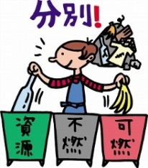

The garbage problem is an issue we are all familiar with, and one that impacts on the planet, environment, and natural resources.

Throwing out garbage that contains harmful substances not only damages the environment, but also has an impact on human health. It is only by disposing of garbage in a sanitary manner and with consideration to the environment, that we can truly protect both our health and the environment itself.

Currently, around 3/4 of all garbage is incinerated, but as the volume of garbage increases, the amount of Co2 released during the incineration process also rises. Reducing garbage is an extremely important issue that directly affects both the environment and our natural resources.

かてい

The rules for separating garbage vary by municipality, but the marks displayed on products and packaging will help you when separating household waste.

|  |  |  |
| --- | --- | --- |
| **C:\Users\オーナー\Desktop\suchiru2.gif** | https://encrypted-tbn0.gstatic.com/images?q=tbn:ANd9GcQ5nIHH1OsZViiP6tMIHnQ-X37qIygaadZDwpt6w62rzvl5jMRG | Steel cans are used for a large number of coffee beverages。  Wash such cans out and place them in the steel recycling bin. |
| **C:\Users\オーナー\Desktop\recycle1.gif** | C:\Users\オーナー\Desktop\almi1.gif | Aluminium cans are used for most beer and carbonated beverages.  Wash such cans out and place them in the aluminium recycling bin. |
| C:\Users\オーナー\Desktop\pura5.gif | C:\Users\オーナー\Desktop\img_sheet2_9.jpg | This mark can be found on such things as the packaging of confectionary goods, frozen food bags, carrier bags, PET bottle lids and labeling, cup noodle containers, shampoo and detergent containers, mayonnaise and ketchup bottles, egg packs, and food trays. |
| C:\Users\オーナー\Desktop\pet3.gif | https://encrypted-tbn0.gstatic.com/images?q=tbn:ANd9GcRnQUmfFvW-rBClhEXgVER60JYfyHCudgAP2YKNw2S6geR2Rua1 | This mark is found on the labeling and on the bottom of soft drink, soy sauce, alcoholic beverage, and dairy drink PET bottles. |
| 紙リサイクルマーク | [https://encrypted-tbn2.gstatic.com/images?q=tbn:ANd9GcSL6KJt4S1CFU1ArL_zKL9RSYvxfZ9zdBVtnjjtFN4poFuLZSf-Xw](https://www.google.co.jp/imgres?imgurl=http://www.ac-illust.com/illust_data/000006/006447/006447m.jpg&imgrefurl=http://www.ac-illust.com/main/detail.php?id=6447&docid=ho71F238DkwRKM&tbnid=vF76eb4gs_JK9M:&w=420&h=591&ei=ZRcNVJT3LY2A8QX4-oLYBA&ved=0CAIQxiAwAA&iact=c) | This mark can be found on product packaging made mainly from paper. These things include paper cups, wrapping paper, paper bags, and paper cartons. |

Weeds, leaves, and branches

[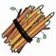](https://www.google.co.jp/imgres?imgurl=http://www.meti.go.jp/policy/recycle/main/data/illust/image/gif/sa-gyou/senteieda01.gif&imgrefurl=http://www.meti.go.jp/policy/recycle/main/data/illust/sa.html&docid=JkmN6NYoW_wndM&tbnid=un29j9s-f3eiuM:&w=71&h=71&ei=0f8MVOj4HMyB8gX__4DIBA&ved=0CAIQxiAwAA&iact=c)[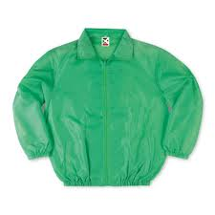](https://www.google.co.jp/imgres?imgurl=http://www.geki-t.com/itemimg/cr3101.jpg&imgrefurl=http://www.geki-t.com/&docid=kVuD6Sm8oC-aIM&tbnid=y1kcq9gq8Qv_0M:&w=400&h=400&ei=B_sMVNmXC5HY8gWXx4HoBA&ved=0CAIQxiAwAA&iact=c)[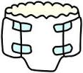](https://www.google.co.jp/imgres?imgurl=http://www.city.otsuki.yamanashi.jp/health/korei/images/2010-0319-1608_0.jpg&imgrefurl=http://www.city.otsuki.yamanashi.jp/health/korei/kaigo_12.html&docid=D1sRWeI2bZyQqM&tbnid=04aHIQeuhbnXsM:&w=147&h=129&ei=1PkMVIw7j6fwBciCgYgC&ved=0CAIQxiAwAA&iact=c)

[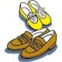](https://www.google.co.jp/imgres?imgurl=http://blog-imgs-69.fc2.com/k/o/j/kojimatomio/00II5871516.jpg&imgrefurl=http://kojimatomio.blog.fc2.com/blog-category-5.html&docid=isEPIBRB_1xv_M&tbnid=BiGo8RgJdhvBwM&w=450&h=450&ei=TvsMVLnuMYeA8gWU84LoBA&ved=0CAMQxiAwAQ&iact=c)

Burnable

You can only dispose of 2 bags on a single collection day.

[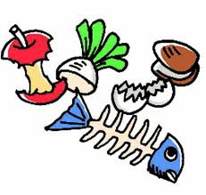](https://www.google.co.jp/imgres?imgurl=http://homepage3.nifty.com/ichikawa_hp/_src/sc291/9.jpg&imgrefurl=http://homepage3.nifty.com/ichikawa_hp/album/c.html&docid=v9-8AEo09pa-fM&tbnid=e54hMEkCBPIWXM:&w=692&h=656&ei=YfoMVNm9AdSD8gWOsoC4BA&ved=0CAIQxiAwAA&iact=c)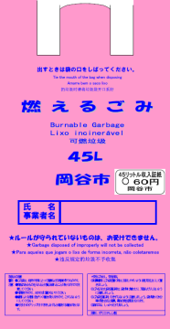

[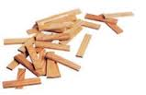](https://www.google.co.jp/imgres?imgurl=http://www.yokotaya.net/kapla_img/kapla_parts.jpg&imgrefurl=http://www.yokotaya.net/kapla.html&docid=aIXAB6aEsqe9oM&tbnid=xXpaP6DsNhcIvM:&w=199&h=129&ei=XxUNVKCKCoG58gWRpIGABQ&ved=undefined&iact=c)

[](https://www.google.co.jp/imgres?imgurl=http://image.space.rakuten.co.jp/lg01/00/0000095600/25/img61fa317ewjuff3.png&imgrefurl=http://plaza.rakuten.co.jp/rakurakutuuhan/diary/200610150000/&docid=URuV0gBYSLyNLM&tbnid=HYRx1LMhTaST1M:&w=444&h=211&ei=bgANVLD2GczM8gX7koK4Ag&ved=0CAIQxiAwAA&iact=c)

Write your name on a transparent bag

[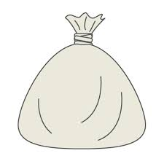](https://www.google.co.jp/imgres?imgurl=http://free-illustrator.com/sozai/37trash/03l.jpg&imgrefurl=http://free-illustrator.com/37trash/03-trash.html&docid=hF3lo5gWWM-gJM&tbnid=MC_PwBi1y94thM:&w=500&h=500&ei=mwINVL7hDJCB8QXfqoLwBA&ved=0CAIQxiAwAA&iact=c)

[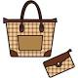](https://www.google.co.jp/imgres?imgurl=http://e-poket.com/illust/img/illust/matu093.jpg&imgrefurl=http://e-poket.com/illust/matu093.htm&docid=ux8IJ6sC-N_h5M&tbnid=JowCYq1PW5bTNM&w=400&h=400&ei=lPsMVLnaKc3d8AXbxoKIBQ&ved=0CAUQxiAwAw&iact=c)

Name

Remove all metal parts

[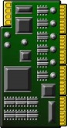](https://www.google.co.jp/imgres?imgurl=http://illustcut.com/box/pc_syuuhen/parts/kiban01.png&imgrefurl=http://illustcut.com/?p=835&docid=yhe5_nQAahds_M&tbnid=Y4-BlLsq4iq6GM:&w=199&h=375&ei=xAkNVNTeFofi8AXUmgE&ved=0CAIQxiAwAA&iact=c)[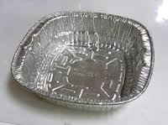](https://www.google.co.jp/imgres?imgurl=http://ryuscafe.c.blog.so-net.ne.jp/_images/blog/_0a5/ryuscafe/E382A2E383ABE3839FE98D8B.jpg?c=a1&imgrefurl=http://ryuscafe.blog.so-net.ne.jp/archive/c35377542-1&docid=HL0GjLpZWqH7yM&tbnid=Y6MatXrFjRWPxM:&w=250&h=187&ei=1xMNVIPzLcfX8gXghoDIBA&ved=undefined&iact=c)[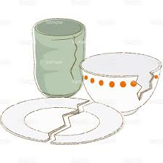](https://www.google.co.jp/imgres?imgurl=http://www.templatebank.com/images/creators/preview/239_0007_L.jpg&imgrefurl=http://www.templatebank.com/gold/creators/dli.asp?id=239_0007&docid=vUW32Zwmt5sgIM&tbnid=E5nC805kab33sM:&w=500&h=500&ei=iwgNVOzZIIf48QW9o4LQBA&ved=0CAIQxiAwAA&iact=c)[](https://www.google.co.jp/imgres?imgurl=http://www.meti.go.jp/policy/recycle/main/data/illust/image/gif/a-gyou/arumihoiru01.gif&imgrefurl=http://www.meti.go.jp/policy/recycle/main/data/illust/a.html&docid=6oLgwUsfi-PLvM&tbnid=-euA4J3AJNrBEM:&w=71&h=71&ei=cBMNVJRfi_bxBevSgNAE&ved=0CAIQxiAwAA&iact=c)

Non-burnable

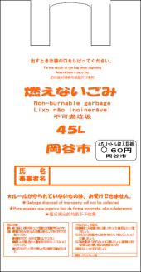

Circuit boards

[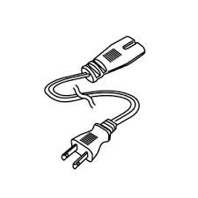](https://www.google.co.jp/imgres?imgurl=http://www.jefcom.co.jp/item_photo/PT4N-AP1800_01.jpg&imgrefurl=http://www.jefcom.co.jp/detail3/1414/7018/&docid=dWK5m40Gi7vLRM&tbnid=Fq7op1O20HZ8yM:&w=300&h=300&ei=igkNVMbKA9H_8QXu3IKQDw&ved=0CAIQxiAwAA&iact=c)

Aluminium trays

Glass & pottery

Tin foil

[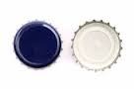](https://www.google.co.jp/imgres?imgurl=http://cache4.asset-cache.net/xt/179255837.jpg?v=1&g=fs1|0|SKP145|55|837&s=1&imgrefurl=http://www.thinkstockphotos.jp/royalty-free/%E7%93%B6%E3%81%AE%E3%82%AD%E3%83%A3%E3%83%83%E3%83%97-pictures&docid=m3GnYwAu05TuqM&tbnid=MYCxdbBsY7FSKM:&w=170&h=113&ei=oQoNVJjhOsHd8AXz9oDQBw&ved=0CAIQxiAwAA&iact=c)[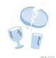](https://www.google.co.jp/imgres?imgurl=http://t.pimg.jp/005/127/422/1/5127422.jpg&imgrefurl=http://pixta.jp/tags/%E3%82%AC%E3%83%A9%E3%82%B9%E3%82%B3%E3%83%83%E3%83%97?search_type=2&docid=Ur_yrPSpQ-4WVM&tbnid=tB63jgqUEBkYHM&w=450&h=468&ei=zhQNVNvSMYSF8gWks4DoBQ&ved=0CAYQxiAwBA&iact=c)[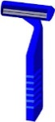](https://www.google.co.jp/imgres?imgurl=http://blog-imgs-11.fc2.com/o/e/k/oekaki777/higesori.gif&imgrefurl=http://oekaki777.blog78.fc2.com/blog-entry-118.html&docid=6GzbUS_zKBE13M&tbnid=VCcnHuxFl8oJtM:&w=143&h=310&ei=7wgNVLGrEJGA8QW3_4HYAQ&ved=0CAIQxiAwAA&iact=c)

[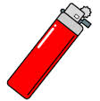](https://www.google.co.jp/imgres?imgurl=http://www.chw.jp/ikkrwebBrowse/material/image/group/17/lighter.gif&imgrefurl=http://www.chw.jp/life_mokuteki/gomi_recycle/1360646249848.html&docid=4r4VOf9e_tf3DM&tbnid=wpmaoFXqUdxdDM:&w=141&h=142&ei=SwkNVJanGY3-8QWmzIKwDQ&ved=0CAIQxiAwAA&iact=c)

Bottle lids

Sort papers and tie them in bundles

[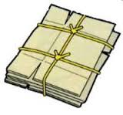](https://www.google.co.jp/imgres?imgurl=https://www.city.minoh.lg.jp/seibi/images/danboul_image.jpg&imgrefurl=https://www.city.minoh.lg.jp/seibi/sinnbunn.html&docid=Y30xZ82WLbmzNM&tbnid=cVQW78u0UmX_aM:&w=200&h=187&ei=tPwMVPytJMvi8AWFpYHYBw&ved=0CAIQxiAwAA&iact=c)[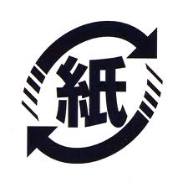](https://www.google.co.jp/imgres?imgurl=http://www.city.soka.saitama.jp/ct/image000018500/kaminorecyclemark.gif&imgrefurl=http://www.city.soka.saitama.jp/cont/s1702/a03/a01/06.html&docid=R3T0w120bjSBNM&tbnid=VoYvoquHnQ9OrM:&w=479&h=476&ei=kRgNVKTwO9WE8gXnsYGQCA&ved=0CAIQxiAwAA&iact=c)

Other papers

Paper

[](https://www.google.co.jp/imgres?imgurl=http://www.city.usa.oita.jp/uploaded/image/771.jpg&imgrefurl=http://www.city.usa.oita.jp/soshiki/11/708.html&docid=vOah3bSxQLToPM&tbnid=fMCbS3AucAvmrM:&w=250&h=165&ei=tRYNVLT7Bc3q8AWPt4CIBQ&ved=0CAIQxiAwAA&iact=c)

[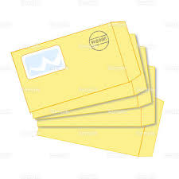](https://www.google.co.jp/imgres?imgurl=http://www.templatebank.com/images/creators/preview/busi4_028_L.jpg&imgrefurl=http://www.templatebank.com/gold/creators/dli.asp?id=busi4_028&docid=oOwiaNGFie3b7M&tbnid=fv0cUtBtDOm_KM:&w=500&h=500&ei=5hkNVIS3OsnZ8gWg84L4BA&ved=0CAIQxiAwAA&iact=c)[](https://www.google.co.jp/imgres?imgurl=http://free-illustrations-ls01.gatag.net/images/lgi01a201401282200.jpg&imgrefurl=http://free-illustrations.gatag.net/tag/%E7%B4%99/page/3&docid=S-cOiM3SOd6wYM&tbnid=WiG1qJFRbV4ShM:&w=1024&h=871&ei=hRkNVL2jHIqC8gXNrIGYBg&ved=0CAIQxiAwAA&iact=c)

[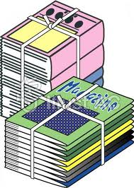](https://www.google.co.jp/imgres?imgurl=http://www.ac-illust.com/illust_data/000006/006447/006447m.jpg&imgrefurl=http://www.ac-illust.com/main/detail.php?id=6447&docid=ho71F238DkwRKM&tbnid=vF76eb4gs_JK9M:&w=420&h=591&ei=ZRcNVJT3LY2A8QX4-oLYBA&ved=0CAIQxiAwAA&iact=c)

[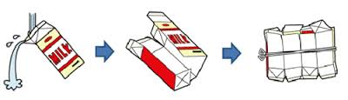](https://www.google.co.jp/imgres?imgurl=http://www.city.saijo.ehime.jp/khome/kankyoeisei/oshirase/gyunyupack.gif&imgrefurl=http://www.city.saijo.ehime.jp/khome/kankyoeisei/oshirase/tempuraaburakaishu.html&docid=p0A8mu-Aoq_X9M&tbnid=-Vpg7f3li5DuwM:&w=500&h=144&ei=JxgNVIyJKcLf8AXkzYLIBA&ved=0CAIQxiAwAA&iact=c)

Place them in a paper bag or cardboard box with written on it

[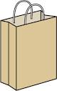](https://www.google.co.jp/imgres?imgurl=http://www.sashienomori.com/110510/paperbag110510.png&imgrefurl=http://www.sashienomori.com/japanese/zakka2.html&docid=KlaBGI7o-B_cuM&tbnid=XFIw_rLJMcvurM&w=251&h=394&ei=QV4NVM6HBYeE8gW05oGgBQ&ved=0CAMQxiAwAQ&iact=c)

[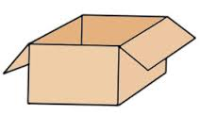](https://www.google.co.jp/imgres?imgurl=http://stat.ameba.jp/user_images/20110725/16/yuki-beans/f3/96/j/o0266015411372812126.jpg&imgrefurl=http://ameblo.jp/yuki-beans/entry-10964765705.html&docid=MPFnoZ0GBinNfM&tbnid=EdTK0HtalB41QM:&w=266&h=154&ei=wF0NVNnBAs3t8AXMwoLYDw&ved=0CAIQxiAwAA&iact=c)

Wash and dry paper cartons

[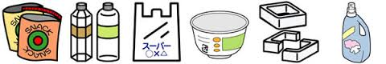](https://www.google.co.jp/imgres?imgurl=http://www.city.ichikawa.lg.jp/common/000144860.jpg&imgrefurl=http://www.city.ichikawa.lg.jp/env04/1111000113.html&docid=YCIBSmHZYmxj3M&tbnid=bzhIiO7D_XQ1BM:&w=600&h=100&ei=PD8SVM-YDoX98QXX64LoDw&ved=undefined&iact=c)

Plastics

[](https://www.google.co.jp/imgres?imgurl=http://free-illustrator.com/sozai/37trash/03l.jpg&imgrefurl=http://free-illustrator.com/37trash/03-trash.html&docid=hF3lo5gWWM-gJM&tbnid=MC_PwBi1y94thM:&w=500&h=500&ei=mwINVL7hDJCB8QXfqoLwBA&ved=0CAIQxiAwAA&iact=c)[](https://www.google.co.jp/imgres?imgurl=http://illustration.artlesskitchen.com/data/mark/alumi.png&imgrefurl=http://illustration.artlesskitchen.com/?p=406&docid=I-ZIH0e_iB6lWM&tbnid=eZ9SuW2X_6G4EM:&w=160&h=143&ei=T0sSVLm4OcOk8AXC94G4DQ&ved=0CAIQxiAwAA&iact=c)[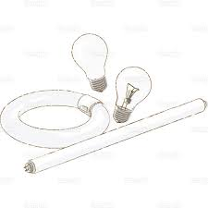](https://www.google.co.jp/imgres?imgurl=http://www.templatebank.com/images/creators/preview/239_0006_L.jpg&imgrefurl=http://www.templatebank.com/gold/creators/dli.asp?id=239_0006&docid=tN7R70Gpe1xexM&tbnid=r35cv3LqIvGi2M:&w=500&h=500&ei=pVQSVJfiLsTd8AXlpICIDw&ved=0CAIQxiAwAA&iact=c)[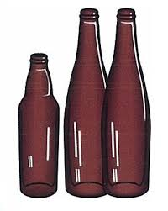](https://www.google.co.jp/imgres?imgurl=http://www.city.chitose.hokkaido.jp/images/content/71734/8_7sigenkaisyu_G.jpg&imgrefurl=http://www.city.chitose.hokkaido.jp/index.cfm/95,71734,165,858,html&docid=RukDfMFNnbEYaM&tbnid=WNwr1fymbbzjEM:&w=288&h=361&ei=5lMSVPrdMZbU8gXkhoDABA&ved=0CAIQxiAwAA&iact=c)[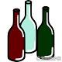](https://www.google.co.jp/imgres?imgurl=http://www.sozaiyakoaki.com/may/akibin/akibin-1.gif&imgrefurl=http://www.sozaiyakoaki.com/may/akibin/&docid=zaG5eI6xQo255M&tbnid=5YKSMMVv4MdTGM&w=200&h=200&ei=YVMSVObnDND08QXfgIGIBw&ved=0CAMQxiAwAQ&iact=c)[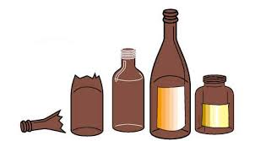](https://www.google.co.jp/imgres?imgurl=http://www.city.nagano.nagano.jp/uploaded/image/9135.jpg&imgrefurl=http://www.city.nagano.nagano.jp/site/kateigomi/2351.html&docid=YtxbZ2l3TXwcsM&tbnid=8zHmHLJTKkSMOM:&w=501&h=277&ei=L1ISVL_lCIn88AWQ5IGYDw&ved=0CAIQxiAwAA&iact=c)[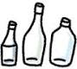](https://www.google.co.jp/imgres?imgurl=http://www.ishikawa.coop/katsudou/img_2/bin.gif&imgrefurl=http://www.ishikawa.coop/katsudou/home_eco.html&docid=BeHYA1ySOfa5hM&tbnid=2jLMvEPIEsZGgM&w=134&h=120&ei=k1ESVJGBOYOm8AW_iYDgAg&ved=0CAQQxiAwAg&iact=c)[](https://www.google.co.jp/imgres?imgurl=http://free-illustrator.com/sozai/37trash/03l.jpg&imgrefurl=http://free-illustrator.com/37trash/03-trash.html&docid=hF3lo5gWWM-gJM&tbnid=MC_PwBi1y94thM:&w=500&h=500&ei=mwINVL7hDJCB8QXfqoLwBA&ved=0CAIQxiAwAA&iact=c)[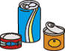](https://www.google.co.jp/imgres?imgurl=http://www.green-sys.com/IMAGES/greenstation/img-kan.gif&imgrefurl=http://www.green-sys.com/greenstation/item/index.html&docid=tBB5LcWvDNsFSM&tbnid=4-Deuggtly2jWM:&w=98&h=77&ei=V04SVNfxE8LV8gWAwYEQ&ved=0CAIQxiAwAA&iact=c)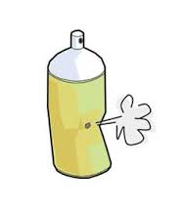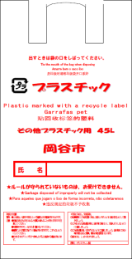[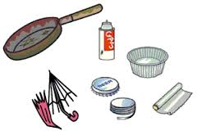](https://www.google.co.jp/imgres?imgurl=http://www.city.katsushika.lg.jp/dbps_data/_material_/_files/000/000/001/974/12458-1.gif&imgrefurl=http://www.city.katsushika.lg.jp/32/152/001974.html&docid=J3sbO05wWyAoEM&tbnid=gQy0CILfWr_sZM:&w=300&h=201&ei=eU8SVO2EKJDr8AW2toGYBg&ved=0CAIQxiAwAA&iact=c)[https://encrypted-tbn1.gstatic.com/images?q=tbn:ANd9GcSJanVDnvzn4zN-GVgv8lYDlcsL9AY6y51hU39RxR8vOkhziPdevA](https://www.google.co.jp/imgres?imgurl=http://www.city.ichinomiya.aichi.jp/division/seiso/gomi_rule/img/07-02.gif&imgrefurl=http://www.city.ichinomiya.aichi.jp/division/seiso/gomi_rule/07-kinzoku.html&docid=5YIivPemwxXyjM&tbnid=5PPpYz7G2IHq1M:&w=146&h=50&ei=ElASVJH6B5Xk8AXh3YK4Cg&ved=0CAIQxiAwAA&iact=c)[](https://www.google.co.jp/imgres?imgurl=http://illustration.artlesskitchen.com/data/mark/steal.jpg&imgrefurl=http://illustration.artlesskitchen.com/?p=440&docid=nt9GnwcFaAa2QM&tbnid=ZCcKYYc1y2wjHM:&w=160&h=160&ei=0E0SVNfkEZTq8AWth4HoAQ&ved=0CAIQxiAwAA&iact=c)[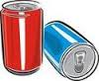](https://www.google.co.jp/imgres?imgurl=http://images.clipartlogo.com/files/ss/thumb/806/80645350/red-and-blue-aluminum-cans-over_small.jpg&imgrefurl=http://jp.clipartlogo.com/premium/detail/aluminum-can-templates_119027569.html&docid=uoh5SwIEuNd4EM&tbnid=kgJ0GPaJWVBIwM:&w=125&h=103&ei=YEwSVPnJHpH48AWr9YLoAQ&ved=0CAIQxiAwAA&iact=c)[](https://www.google.co.jp/imgres?imgurl=http://www.city.chino.lg.jp/www/contents/1000000729000/simple/130308081506_0.png&imgrefurl=http://www.city.chino.lg.jp/www/contents/1000000729000/index.html&docid=NYOsaOmuhjb3cM&tbnid=OdHXRRrUA-72rM&w=134&h=125&ei=jD4SVP6fII748QWU_4DoCg&ved=0CAMQxiAwAQ&iact=c)[](https://www.google.co.jp/imgres?imgurl=http://www.sozai-library.com/wp-content/uploads/2013/06/00697-450x337.jpg&imgrefurl=http://www.sozai-library.com/sozai/697&docid=k654GC3CNYfy8M&tbnid=tBianruI1nhCdM:&w=450&h=337&ei=qkgSVLTAKovy8QWX8oHoCg&ved=0CAIQxiAwAA&iact=c)[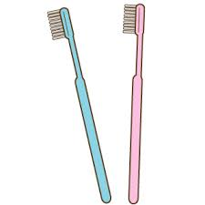](https://www.google.co.jp/imgres?imgurl=http://livedoor.blogimg.jp/illustrationm/imgs/4/1/4149bb46.gif&imgrefurl=http://illustration-card.livedoor.biz/tag/%E6%AD%AF%E3%83%96%E3%83%A9%E3%82%B7&docid=hWh43Xrf0qdUzM&tbnid=UVDAVYEVkPaB5M:&w=320&h=320&ei=XkgSVN7sOZfZ8gWSkYLgAQ&ved=0CAIQxiAwAA&iact=c)[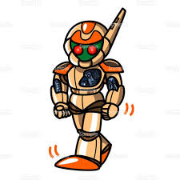](https://www.google.co.jp/imgres?imgurl=http://www.templatebank.com/images/creators/preview/006_0046_L.jpg&imgrefurl=http://www.templatebank.com/gold/creators/dli.asp?id=006_0046&docid=dvSJ1HB5vsEwmM&tbnid=tD9-FQBHpnhtFM:&w=500&h=500&ei=8UgSVP7bIM3m8AXI8IGQDA&ved=0CAIQxiAwAA&iact=c)[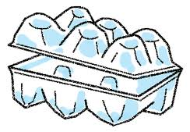](https://www.google.co.jp/imgres?imgurl=http://www.city.yokohama.lg.jp/kohoku/kids/g30/image/egg.gif&imgrefurl=http://www.city.yokohama.lg.jp/kohoku/kids/g30/announce5-no.html&docid=u2KxZiRh9a_ayM&tbnid=lM8NJjroMDSSNM:&w=305&h=212&ei=Rz8SVOqRJY2B8gXuyIJY&ved=0CAIQxiAwAA&iact=c)[https://encrypted-tbn0.gstatic.com/images?q=tbn:ANd9GcRP4gEeZTQxpQD_jRtS4sy9qnuKL2H1J6BLiIW2Npa9rMZFvnGT](https://www.google.co.jp/imgres?imgurl=http://www.town.inagawa.hyogo.jp/dept/03111/d006159_d/img/017.png&imgrefurl=http://www.town.inagawa.hyogo.jp/dept/03111/d006159.html&docid=m8SsR8gxpLlaCM&tbnid=m7l44bEcxiOVZM:&w=102&h=60&ei=bUQSVKyRH4b_8QX4zYLoDA&ved=0CAIQxiAwAA&iact=c)

Write your name on a transparent bag

Aluminium Cans

Plastics without this mark should be treated as burnable garbage.



Place them in the package they were purchased in or wrap in paper before throwing out

Place them to the side of the recycle bin

Brown glass

Other glass

Clear glass

Take them to the garbage disposal area and sort them correctly

Write your name on a transparent bag

Metals

Name

氏　名

Rusted metal is also OK

Write your name on a transparent bag

Aluminiu*m*

Name

Refillable bottles

Light bulbs

Make sure to puncture aerosol cans

Remove plastic and fabric from umbrellas

Steel

Name

Make sure the contents are emptied and that plastic containers and packaging are rinsed and wiped clean before being disposed of.

Glass

Metals

Steel Cans

**[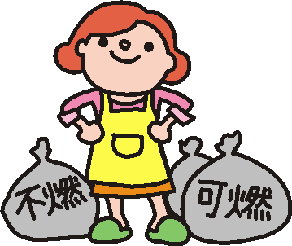](http://www.google.co.jp/url?sa=i&rct=j&q=&esrc=s&frm=1&source=images&cd=&cad=rja&docid=nBBclaRr1Raw-M&tbnid=Qbg48Oh3HomOtM:&ved=0CAUQjRw&url=http://www.city.chita.aichi.jp/seikatsukankyou/seisougyoumu/shushubi&gomi/shuushuugetumoku.html&ei=3L1tUvj3NIj-rAfHxoCICQ&bvm=bv.55123115,d.aWc&psig=AFQjCNEfSItwoWAW9njgpzrWZQZpnCIL5g&ust=1383010106229716)**

[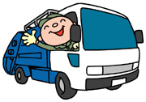](http://www.google.co.jp/url?sa=i&rct=j&q=&esrc=s&frm=1&source=images&cd=&cad=rja&docid=_N22-j86lBjgBM&tbnid=T6iIMefjEZUw7M:&ved=0CAUQjRw&url=http://www.city.ashiya.lg.jp/kankyoushori/index.html&ei=7r5tUp_PNMSmrQfxwoCoCQ&bvm=bv.55123115,d.aWc&psig=AFQjCNE84PZxmmpDUIRcpLPSn1pY_z_bKA&ust=1383010198027842)

Garbage can no longer be taken to and disposed of at the Okaya Waste Incineration Plant (O.W.I.P.). Instead, we ask that you use the temporary garbage disposal facility at Yamabiko Park (details below). This site will be in operation until the new Suwako Green Center opens in 2016.



**○Items that can be disposed of**

* Burnable and non-burnable garbage in the correct tax-paid trash bags.
* Cut grass, weeds, and other garden trash in clear plastic bags.
* Wood that cannot be chipped is accepted if bundled in pieces with a length less than 60cm and a diameter less than 30cm. (Please note that bamboo, trees, and tree roots, that are diseased, poisonous or have thorns cannot be chipped.)
* Branches and twigs that can be chipped. (Diameter less than 17cm and length less than 180cm)

**Temporary Garbage Disposal Area** (T.G.D.A.)

Yamabiko Park Car Park 6

To Route 20

Park Office

Skate Center

O.W.I.P.

**×Items that cannot be disposed of**

* Over-sized garbage too big for designated tax-paid trash bags. (Futons, carpet, storage boxes, broken furniture, buckets and containers used for making pickles, planters, large fish tanks, large mirrors, glass etc...)
* Recyclable items. (Paper, cloth, empty cans, metal etc...)
* Dead pets

To Okaya Station

T.G.D.A.

**Open Mon-Sat 9am to 12pm, Nov 1st 2013 - Aug 31st 2016.**

*\*Closed Sundays, public holidays, Aug 15 -16 and Dec 29 - Jan 3.*

**１.Food and Shopping**

◆Use your own shopping bag when shopping.

◆Buy food in smaller quantities.

◆Plan meals carefully so as not to waste leftovers.

◆Cook smaller portions.

**2.Reuse**

◆Make use of recycle shops and flea markets.

◆Use refill packs and bottles etc...

◆Repair items and make the most out of them.

**3.Recycle**

◆Separate trash and recycle papers, glass bottles, metals, plastics, food waste etc...

**1**